Que 1)

1. Ipconfig

ipconfig stands for "Internet Protocol Configuration". ipconfig is a console application program that displays the IP address and subnet mask of your device.

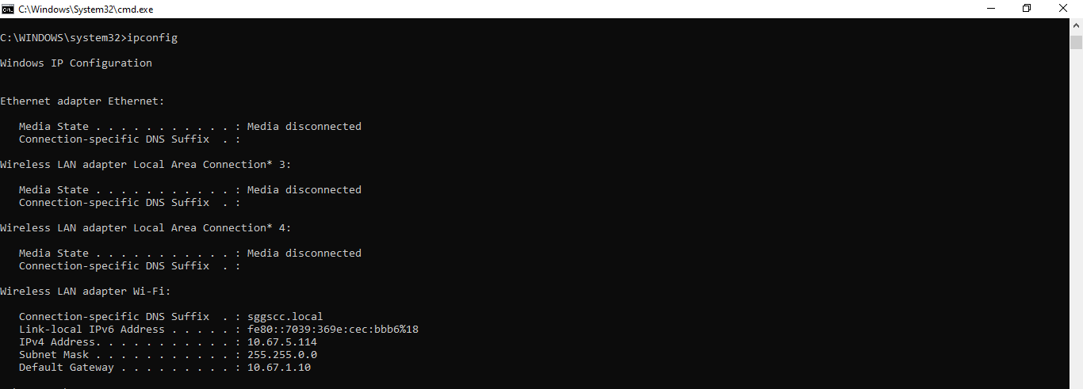

1. Ping

Ping stands for “Packet Internet or Inter-Network Groper”. Ping is a basic Internet programme that allows a user to test and verify if two or more devices are connected within the same network.

For example, take device A and device B connected to the same college Wifi. Then run ping_IPAddress of device B in device A. If device A accepts the request then device A and B are pinging. If device A rejects the request then they are not pinging.

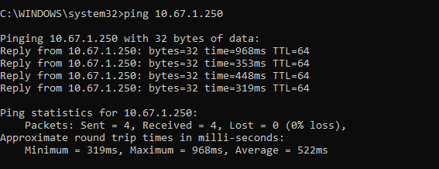

1. telnet

TELNET stands for Teletype Network. It is a type of protocol that enables one computer to connect to the local computer.

1. Ssh

Secure Shell is a network communication protocol that enables two computers to communicate and share data.

1. tracert/traceroute

tracert provides a map of how data on the internet travels from its source to its destination and shows how many routers are there between a network.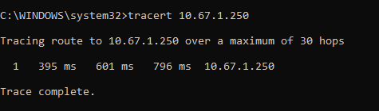

Que 2)

A Ping (Packet Internet or Inter-Network Groper) is a basic Internet programme that allows a user to test and verify if two or more devices are connected within the same network.

For example, take device A and device B connected to the same college Wifi. Then run ping_IPAddress of device B in device A. If device A accepts the request then device A and B are pinging. If device A rejects the request then they are not pinging.



Netstat

In computing, netstat (network statistics) is a command-line network utility that displays network connections between the ingoing and outgoing connectivity of our device.

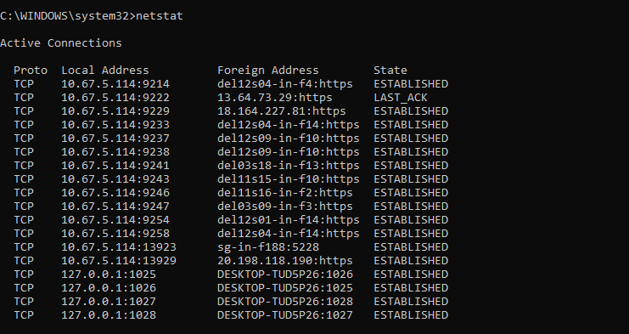

Que 3)



Class Name = Class A

Host ID = 10.67.5.114

Max no. of subnets = 2^8 = 256

Subnet address of the host = 10.65.0.0

10.67.5.114 = 00001010.01000001.00000101.01110010

00001010.01000001.00000000.00000000 - 00001010.01000001.11111111.11111111